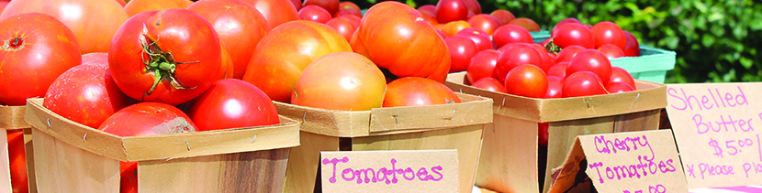
Vendor Application: McKenney Farmers Market
Contact Information
Name of Business: _______________________________________________________________________________________
Virginia State Tax No.: ___________________________________________________________________________________
Contact Person: _________________________________________________________________________________________
Phone: ___________________________________ E-Mail Address: ________________________________________________
Address: _______________________________________________________________________________________________
***Produce and those processed foods that are regulated by the Virginia Department of Agriculture and Consumer Services and Artists that produce and sell their own handmade products, will be considered for space in the market.
Please provide a brief description of the products that you plan to sell. If you feel your products will fall into an area of question, please go into more detail to describe them on a separate page and we will evaluate them.
_______________________________________________________________________________________________________
_______________________________________________________________________________________________________
_______________________________________________________________________________________________________
Vendor Responsibilities
1. Vendors are responsible for collecting their own sales tax when it is applicable. (Contact the Dinwiddie County Commissioner of Revenue if you have questions).
2. Vendors understand that the Town of McKenney, Dinwiddie County, its members and volunteers are not responsible for any accident, liabilities or problems which may occur before, during, or after the market closes.
3. Vendors must submit their vendor fees to the market manager prior to the start of the market.
4. All regulations of the market will be followed and will be furnished in a separate document. Vendors have read them and agree to abide by them.
Applications may be mailed to P.O. Box 309, McKenney, VA 23872, or delivered to Town Hall (20707 First Street, McKenney, VA 23872) Tues/Fri between 2:00 and 6:00 p.m.
By signing this application, you are agreeing to the Rules and Regulations of the Town of McKenney Farmers Market.
Yes: No:
Fee Paid:
Signature: ______________________________________________________ Date: ________________________

