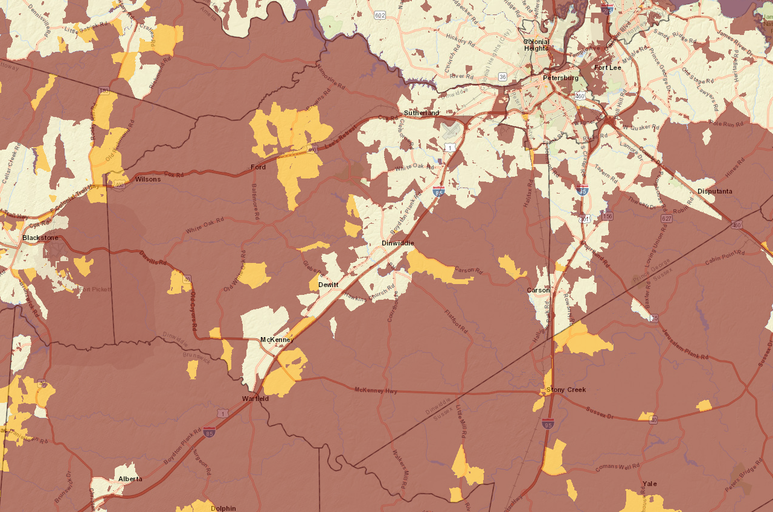
Yellow areas are underserved (<25/3) and burgundy areas are unserved (<10/1)
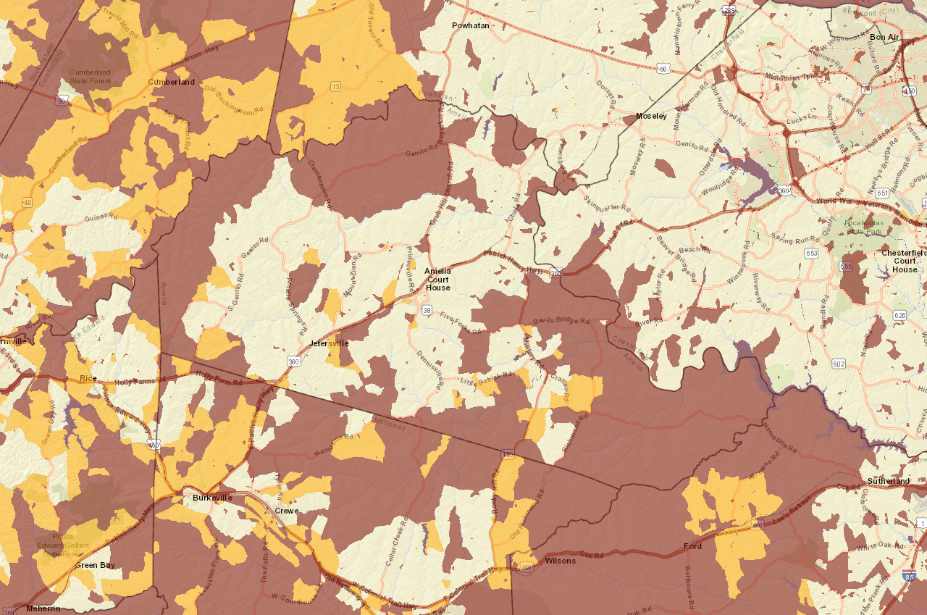
Yellow areas are underserved (<25/3) and burgundy areas are unserved (<10/1)

